**FULL STACK WEB DEVELOPMENT**

**( DIGITAL ASSIGNMENT – 1 )**

**NAME;- MUKUL KUMAR**

**REG NO;- 23MCA1072**

1. Design a webpage for an online Pizza Delivery system using HTML5.

//CODE

<!DOCTYPE html>

<html lang="en">

<head>

    <meta charset="UTF-8">

    <meta name="viewport" content="width=device-width, initial-scale=1.0">

    <link rel="stylesheet" href="style.css">

    <title>Pizza Delivery</title>

</head>

<body>

    <div>

    <header>

        <h1><img id="pic3" src="order.png" alt="">Pizza Delivery</h1>

    </header>

</div>

    <nav>

        <ul>

            <li><a href="#menu">Menu</a></li>

            <li><a href="#order">Order Online</a></li>

            <li><a href="#contact">Contact</a></li>

        </ul>

    </nav>

    <section id="menu">

    <div id="menu1">

        <img id="pic1" src="pizza5.png" alt="">

        <img id="pic2" src="pizza3.png" alt="">

    </div>

    <section id="order">

        <h2>Order Online</h2>

        <form>

            <label for="pizza-type">Select Pizza Type:</label>

            <select id="pizza-type" name="pizza-type">

                <option value="cheese">Cheese Pizza</option>

                <option value="pepperoni">Pepperoni Pizza</option>

                <option value="veggie">Veggie Pizza</option>

                <option value="Chicken">Chicken Pizza</option>

            </select>

            <label for="quantity">Quantity:</label>

            <input type="number" id="quantity" name="quantity" min="1" value="1">

            <label for="Address">Address:</label>

            <input type="text" id="name" name="name" required minlength="10" maxlength="100" size="50" />

            <button type="submit">Place Order</button>

        </form>

    </section>

    <section id="contact">

        <h2>Contact Us</h2>

        <p>Have questions or need assistance? Contact us at:</p>

        <address>

            Email: <a href="mailto:vit@pizzadelivery.com">vit@pizzadelivery.com</a><br>

            Phone: <a href="tel:xxxxxxxx">+91 0000000000</a>

        </address>

    </section>

    <footer>

        <p>&copy; 2023 Pizza Delivery</p>

    </footer>

</body>

</html>

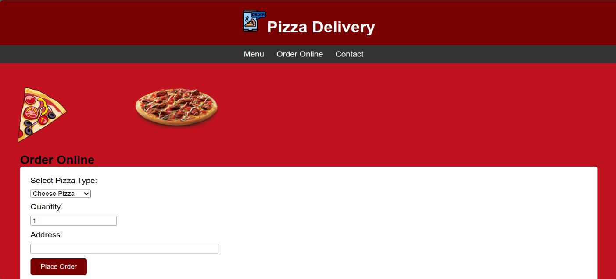

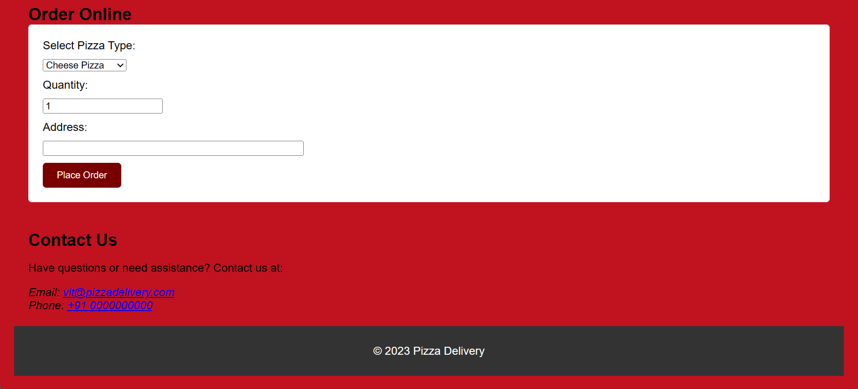FGDFG

1. Develop an online COVID-19 tracker using HTML and JavaScript. Design the web page with three textboxes to fetch the number of newly infected cases on a particular day corresponding to three states. Create a button to add the count to the existing cases of the three states. Use DOM property event handling to update the count when the button is clicked and alert which state has maximum cases for every submission of the button. The total number of cases could be the same for any two or all the three states. In such case it should alert the name of all the states with similar count. Both name and count must be displayed.

//CODE

<html>

<body>

    <label>State 1: Gujarat</label>

    <input type="text" id="state1">

    <label>State 1: Bihar</label>

    <input type="text" id="state2">

    <label>State 1: Tamil nadu</label>

    <input type="text" id="state3">

    <button id="btn">Count cases</button>

    <script>

        let btn = document.getElementById("btn");

        let case1 = 0, case2 = 0, case3 = 0;

        btn.addEventListener("click", function () {

            let state1Count = document.getElementById("state1").value;

            let state2Count = document.getElementById("state2").value;

            let state3Count = document.getElementById("state3").value;

            case1 = case1 + parseInt(state1Count);

            case2 = case2 + parseInt(state2Count);

            case3 = case3 + parseInt(state3Count);

            if (case1 > case2 && case1 > case3) {

                alert("Gujarat has highest cases: " + state1Count)

            } else if (case2 > case1 && case2 > case3) {

                alert("Bihar has highest cases");

            } else if (case3 > case1 && case3 > case2) {

                alert("Tamilnadu has highest cases");

            } else {

                if (case1 == case2 && case1 == case3 && case2 == case3) {

                    alert("All States");

                } else if (case1 == case3) {

                    alert("Gujarat and Tamilnadu" );

                } else if (case2 == case3) {

                    alert("Bihar and Tamilnadu");

                } else if (case1 == case2) {

                    alert("Bihar and Gujarat");

                } else {

                    alert("IDKKKKKK")

                }

            }

        });

    </script>

</body>

</html>

**OUTPUT;-**

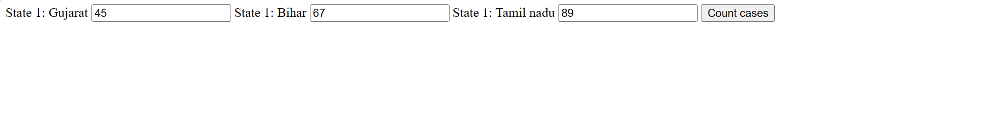

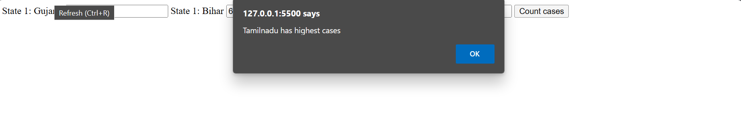

**EX;-3.** Develop an online application for Indian Premier League – 2021 Auction Process using HTML, JavaScript and DOM. The application is an editor for IPL auction result for Chennai Super Kings. The webpage has a heading section with heading “IPL Auction 2021”. Create a button “EditDate” that appends current date to the heading using TextNode method. The webpage also has three sections for player list, newly added batsmen and dropped bowler. Fetch the current set of players from a textbox and add it to the first as a child element using tag when “Add Player” button is clicked. Assume in second there is an unordered list of two batsmen who are to be replaced. Fetch the names of the two new batsmen from two textboxes and on clicking “Replace batsmen” button, replace the previous two batsmen from the unordered list. Assume that the third has an unordered list of 3 bowlers in descending order of performance. Create a button “DropBowler” that deletes the last bowler in the list.

//code

<!DOCTYPE html>

<html lang="en">

<head>

 <meta charset="UTF-8">

 <meta name="viewport" content="width=device-width, initial-scale=1.0">

 <title>IPL AUCTION</title>

</head>

<body>

 <h1 id="heading1">IPL Auction 2023 &nbsp;&nbsp;&nbsp;</h1>

 <button onclick="getDate()">Edit Date</button>

 <br><br>

 <div>

 <h2>Player List</h2>

 <input type="text" id="newPlayer" placeholder="Enter a new Player">

 <button onclick="addPlayer()">Add Player</button>

 <p id="PlayerList">

 </p>

 </div>

 <div>

 <h2>Newly Added Batsman</h2>

 <input type="text" id="newBatsman1" placeholder="Enter first Batsman

1">

 <input type="text" id="newBatsman2" placeholder="Enter second

Batsman 1">

 <button onclick="replacePlayer()">Replace Player</button>

 <ul id="batsmanList">

 <li>Batsman 1</li>

 <li>Batsman 2</li>

 </ul>

 </div>

 <div>

 <h2>Dropped Bowler</h2>

 <button onclick="dropBowler()">Drop Bowler</button>

 <ul id="bowlerList">

 <li>Bowler 1</li>

 <li>Bowler 2</li>

 <li>Bowler 3</li>

 </ul>

 </div>

 <script>

 function getDate(){

 const currentDate=new Date().toLocaleDateString();

 document.getElementById("heading1").append(currentDate);

 }

 function addPlayer(){

 const newPlayer=document.getElementById('newPlayer').value;

 const playerList=document.getElementById('PlayerList');

 const playerItem=document.createElement('p');

 playerItem.textContent=newPlayer;

 playerList.appendChild(playerItem)

 }

 function replacePlayer(){

 const batsman1=document.getElementById('newBatsman1').value;

 const batsman2=document.getElementById('newBatsman2').value;

 const listItem=document.getElementsByTagName('li')

 listItem[0].textContent=batsman1;

 listItem[1].textContent=batsman2;

 }

 function dropBowler(){

 const bowlerList1=document.getElementById('bowlerList')

 const bowlerListItems=document.getElementsByTagName('li');

 if(bowlerListItems.length>0)

 {

 bowlerList1.removeChild(bowlerListItems[bowlerListItems.length-1])

 }

 }

 </script>

</body>

</html>

OUTPUT:-

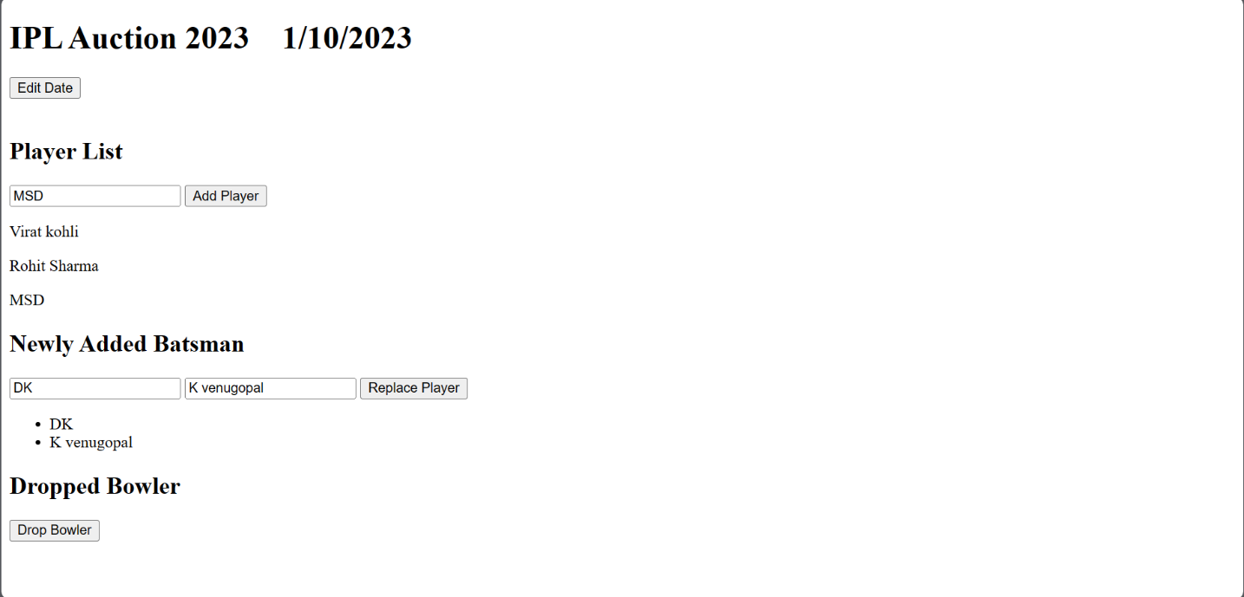

4.CMF Hospital wants you to develop an online application to analyze the cognitive ability of geriatric patients using HTML and JavaScript.

//code

<!DOCTYPE html>

<html lang="en">

<head>

 <meta charset="UTF-8">

 <meta name="viewport" content="width=device-width, initial-scale=1.0">

 <title>CNF Hospital</title>

</head>

<script>

 var b;

 function textbox2()

 {

 t1=parseInt(document.getElementById('txt2').value);

 var a=t1+2;

 document.getElementById('txt2').value=a;

 var b=a*2;

 document.getElementById('txt3').value=b;

 var c=b+1;

 document.getElementById('txt4').value=c;

 var d=c*5;

 document.getElementById('txt5').value=d;

 var x=d-25;

 document.getElementById('txt6').value=x;

 if (x >= 10 && x < 100)

 {

 var y = x.toString();

 var bro = parseInt(y.charAt(0));

 document.getElementById('txt7').value = bro;

 var sis = parseInt(y.charAt(1));

 document.getElementById('txt8').value = sis;

 }

 else if (x >= 0 && x < 10)

 {

 document.getElementById('txt7').value = 0;

 document.getElementById('txt8').value = x;

 }

 else if (x == 0)

 {

 document.getElementById('txt7').value = 0;

 document.getElementById('txt8').value = 0;

 }

 }

 function result()

 {

 m=document.getElementById('txt7').value;

 n=document.getElementById('txt8').value;

 if(m==1 && n==0)

 {

 div1=document.getElementById('textbox8');

 op=document.createElement('h3');

 op1=document.createTextNode("Good memory and problem solving skills");

 op.appendChild(op1);

 div1.appendChild(op);

 }

 else{

 div1=document.getElementById('textbox8');

 op=document.createElement('h3');

 op1=document.createTextNode("Retardation is memory and problem solving skills");

 op.appendChild(op1);

 div1.appendChild(op);

 }

 }

</script>

<body>

 <center><h1>Test your cognitive ability</h1>

 <h3>CNF HOSPITAL</h3>

 <div id="textbox1">

 NAME::<input type="text" id="txt1">

 </div>

 <br/><br/>

 <div id="textbox2">

 BROTHERS::<input type="text" id="txt2"><input type="button" value="click me"

id="btn1" onclick="textbox2()">

 </div>

 <br/><br/>

 <div id="textbox3">

 Textbox 3<input type="text" id="txt3">

 </div>

 <br/><br/>

 <div id="textbox4">

 Textbox 4<input type="text" id="txt4">

 </div>

 <br/><br/>

 <div id="textbox5">

 Textbox 5<input type="text" id="txt5">

 </div>

 <br/><br/>

 <div id="textbox6">

 Textbox 6<input type="text" id="txt6">

 </div>

 <br/><br/>

 <div id="textbox7">

 Brothers:<input type="text" id="txt7">

 </div>

 <br/><br/>

 <div id="textbox8">

 Sisters:<input type="text" id="txt8"><input type="button" value="RESULT"

onclick="result()">

 </div>

</center>

</body>

</html>

**OUTPUT;-**

